**Project Synopsis**

**On**

**Parking Management System**

A mini – project synopsis submitted in partial fulfilment of the requirement for the award of Degree of

**Bachelor of Engineering**

**(Fifth Semester)**

**In**

**COMPUTER SCIENCE & ENGINEERING**

**Session 2022-2023**

**Prescribed By**

**Dr. Babasaheb Ambedkar Technological University, Lonere (DBATU)**



**Guided By**

**Prof. Anand Donald Submitted By**

**Gudiya Prasad (CSEB573)**

**Achal Ragit (CSEB582)**

**Sneha Wankar (CSEB579)**

**Achal Waghmare (CSEB563)**

**DEPARTMENT OF INFORMATION TECHONLOGY**

**RAJIV GANDHI COLLEGE OF ENGINEERING**

**RESEARCH & TECHNOLOGY**

**Table of Content**

|  |  |
| --- | --- |
| 1) | Introduction |
| 2) | Aim and objectives of project |
| 3) | Methodology:  a)software description  b) hardware description |
| 4) | Module description |
| 5) | Algorithm description |
| 6) | Database description |
| 7) | E-R / Class diagram |
| 8) | Expected output |
| 9) | Future scope |
| 10) | Conclusion |
| 11) | Reference |

***ABSTRACT***

Due to the increasing population in urban cities, there is an exponential rise in the number of vehicles which is leading to major problems leading to poor traffic management and congestion. Another major problem faced by the vehicle owners is the availability of parking space. The idea of Smart Cities is slowly gaining pace with the ever increasing technologies. Therefore, in the proposed parking system we are integrating the Wireless Sensor Technology with the Android Application so that the user can book or pre-book a slot. The vehicle owner will be able to reserve a slot for his/her vehicle from anywhere and will be provided with a QR code which will be scanned on the entry of the parking area. Another feature our system provides is providing information about the near-by parking areas which comes handy when the current parking area is full.

**INTRODUCTION**

Now days in many public places such as malls, multiplex systems, hospitals, offices, market areas there is a crucial problem of car parking. The car-parking area has many lanes/slots for car parking. So to park a car one has to look for all the lanes. Moreover this involves a lot of manual labour and investment. So there is a need to develop an automated parking system that indicates directly the availability of vacant parking slots in any lane right at the entrance. The project involves a system including infrared transmitter- receiver pair in each lane and an LED/ LCD display outside the car parking gate. So the person desirous to park his vehicle is well in formed about the status of availability of parking slot. Conventional parking systems do not have any intelligent monitoring system and the parking lots are monitored by security guards. A lot of time is wasted in searching vacant slot for parking and many a times it creates jams. Conditions become worse when there are multiple parking lanes and each lane with multiple parking slots. Use of parking management system would reduce the human efforts and time with additional comfort. In the proposed system, the display unit and the LED sindicate the status of the parking lanes viz. a GREEN LED indicates a vacant slot and a RED LED indicates the unavailability . The system would not only save time but the software and hardware would also manage the Check-in and check-outs of the cars under the control of RFID readers/ tags with additional features of automatic billing, green communication, entry/exit data logging and obstacle indication during parking using ultrasonic sensors.

**AIM**

The aim of implementing Parking Management System is to reduce time and increase efficiency of the current Parking Management System. In overpopulated cosmopolitan zones, parking strategies must be well implemented for management of vehicles. The system provides details of the vacant parking slots in the vicinity and reduces the traffic issues due to illegal parking in the vicinity. It is designed with an objective to meet the requirements of controlled parking that offers effortless parking tactics to the authorities.

**OBJECTIVES**

We can park our vehicle in our own slot by paying.

• Because of that there is no towing problems.

• And our vehicle has been parked as a secure condition.

• There is no risk for vehicle owner for parking the car.

• In case of any damages and problem of vehicle that will claim by parking management.

• As the world is facing many threads daily, robberies are done easily with no track to trace, bomb blasts occur with the use of vehicle, so if a proper system is adopted each and every record can be saved and anyone can be track easily therefore mainly is to make a better and fast software, most important user-friendly

• Maintain records in short time of period.

• Determines the parking area is full or not.

• Enhances the visitor’s experience.

**METHODOLOGY**

1. **SOFTHWARE DESCRIPTION**

1. Supports the languages C and C++ using distinct guidelines of code architecture, which stores a software library from the wiring project, which runs common input and output procedures.
2. MS SQL Server is a client-server architecture that accepts, processes, and replies to the client request with processed data.
3. **HARDWARE DESCRIPTION**
4. **Controller:**

A microcontroller is a small and low-cost computer

built for the purpose of dealing with specific tasks, such

as displaying information in a microwave LED or

1. receiving information from a television’s remote control.

Microcontrollers are mainly used in products that require

a degree of control to be exerted by the user.

1. **Reader:**

An reader's function is to interrogate tags.

The means of interrogation is wireless and because the

distance is relatively short; line of sight between the

reader and tags is not necessary. A reader contains an RF

module, which acts as both a transmitter and receiver of

radio frequency signals.

1. **Sensor:**

An infrared sensor is an electronic device, that emits in

order to sense some aspects of the surroundings. An IR

sensor can measure the heat of an object as well as detects

the motion. These types of sensors measures only infrared

radiation, rather than emitting it that is called as a passive IR

sensor.

**MODULE DESCRIPTION**

**a).Data Records**

* **Staff records**: - It helps to provide details of staff that uses the Vehicle parking management System. It provides the descriptions of staffs like:

-Staff first, middle and last name

-Address

-Contact Number

-Gender.

* **User Records:** - This record helps for the authorization for using Vehicle Parking Management System. It Provides the Username and Password for the User (staff).It also includes the level of authority that means it separates the normal users and administrator.
* **Vehicle Records: -** This most important record which focuses in our Vehicle Parking Management System. It stores the essential Vehicle records like:

-Vehicle Number

-Vehicle Type

-Vehicle Entry Time

-Vehicle Exit Time

**b).Reports**

* **Vehicle Parking Detail: -** This report is very essential in this system. This report provides a brief summary of vehicle activities. It shows the overall Entry and Exit time. It shows the User at time of Entry and Exit .It also provides the facility for examining the total vehicle details according to date wise.
* **Transaction Detail:-**This report will show the Transaction between the customer and the System. . It shows the cost of the vehicle after using the facility of parking. It will show the number of transaction by date wise. It will also have User at time of the Transaction.

**ALGORITHM DESCRIPTION**

These algorithms are based on four techniques. Iterative method that selects an iteration number to repeat a certain procedure in order to select the best solution, is the first technique. The second one is the randomization approach, where a probability value is applied to choose between one vehicle or one parking. Probability value varies according to the chosen algorithm. The third technique is a combination of the two previous techniques. Each combination will give a new algorithm with new results.

The fourth technique is the solution of the two parking problem using the subset-sum problem. The solution of the sub-set problem is inspired by the two parallel machines problem solved using the sub-set problem. Indeed, from the latter work, we call the procedure of sub-set problem to solve the two parking spaces problem. These parking spaces are the most loaded and the least loaded.

In the next subsection, we will use the non-increasing order based procedure denoted by NI. This procedure is based on the following strategy: initially, sort all the vehicles in non-increasing order according to the number of people inside it. The second step is to assign the vehicle that has the greatest number of people to the parking space that has the minimum total number of people. After that, continue in this manner of scheduling until all vehicles are scheduled.

To solve the discussed problem, this research started by collecting the required data, which was analyzed to derive the required parameters. These parameters were used to specify the needed constraints, then to derive the variables and specify the objective functions to obtain maximizing of the minimum to reach the approximate solutions. The obtained solutions will be used to measure the performance metrics, efficiency, and running time calculations. These calculations are the basis to design the developed algorithms that will be the framework of the proposed approach.

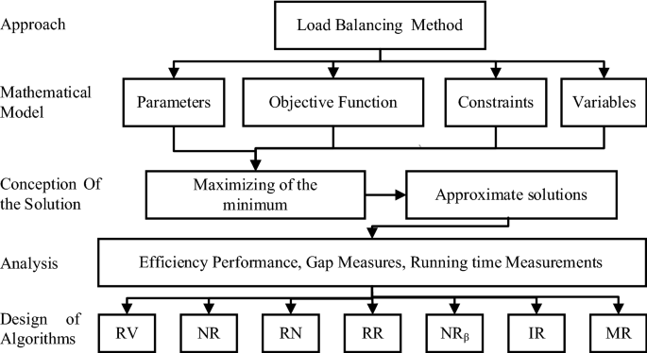

**Iterative random vehicle algorithm (RV)**

Randomization method is utilized to develop this algorithms as follows. First, classify the vehicles into three types. The first type, vehicle is chosen to be scheduled based on vehicle index. The next type is the scheduling of vehicles based on the non-decreasing order of the count of people in the vehicle. The third type is the vehicle scheduling based on the decreasing order of the people count for each vehicle. For a certain type, choose a vehicle randomly from the set of given vehicles. After that, allocate the selected vehicle to the parking space that has the minimum total number of people, then repeat until finishing all vehicles. This process is being repeated for many times. Therefore, for each type, execute the selection of vehicles for *lim* times.

In this context, the function r and (*a*, *b*) is responsible of deriving integers in the range *a* and *b*, while Asg(*j*) is the function that assigns the vehicle *j* to the parking that has the minimum number of people. Let In () be the function that sorts the given vehicles in an increasing order based on the number of people inside it. While, De () be the function that sort the given vehicles in a decreasing order based on the number of people inside it. For RV algorithm the iterations number *lim* is fixed to 1000. This algorithm is denoted by RV and the related execution steps are described in the algorithm.

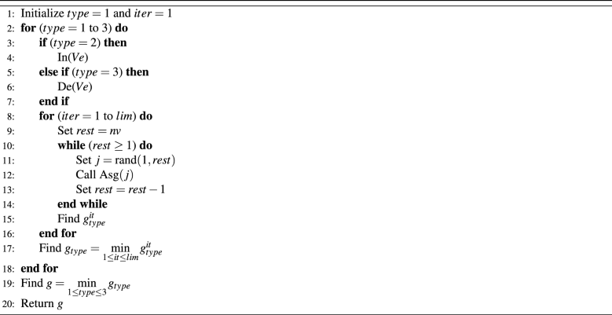

**M-vehicles with NI and random choice algorithm (NR)**

This algorithm works as follows, schedule part of the vehicles using the NI algorithm, then the remaining vehicles are scheduled by applying the random choice of any of the remaining vehicles. The first chosen part is prepared based on a multiplication by the number of parking spaces, which is called the multiplier and is denoted by *M*. To illustrate, apply the NI algorithm for the first 2×np2×np vehicles to be scheduled, the rest of the vehicles will be chosen randomly and will be allocated to the parking space that has the minimum number of people. For this case, the multiplier *M* is equal to 2. Iterate this algorithm for *lim* times. After that increment the multiplier *M* to 3 and so on until M×np<50M×np<50 and M×np<nvM×np<nv. This algorithm is given the name NR and Table [3](https://www.nature.com/articles/s41598-022-10076-4#Tab3) describes the related execution steps.

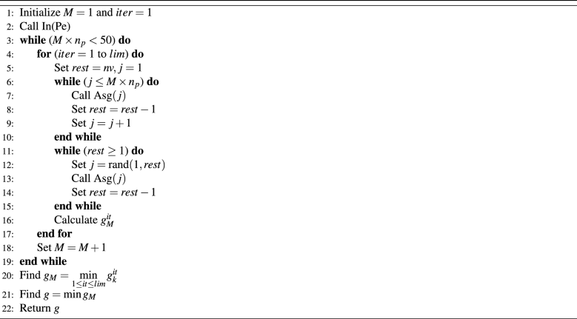

**M-vehicles with randomized-NI and NI algorithm (RN)**

This algorithm works as follows, schedule part of the vehicles using the randomized-NI algorithm, then the remaining vehicles are scheduled by applying the NI algorithm. The first chosen part is performed based on a multiplication by the number of parking spaces, which is called the multiplier and is denoted by *M*. The same iteration which is based on the multiplier *M* adopted for NR will be utilized in this algorithm. This algorithm will be denoted by RN.

In the randomized-NI procedure, the randomization is achieved by selecting a probability αα to choose vehicle with the largest count of people and with 1−α1−α for the next vehicle with the largest number of people . The algorithm given in Table [4](https://www.nature.com/articles/s41598-022-10076-4#Tab4) describes the instructions of the randomized-NI procedure RNI(.). In this algorithm M×npM×np (the input of the procedure) is the set of vehicles that will be set by the multiplier *M* described in NR.

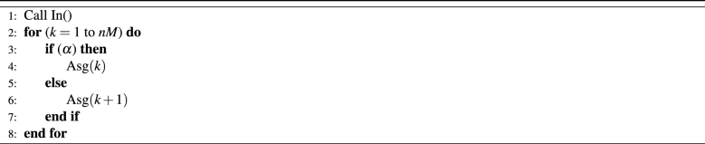

Next, the instructions that elaborate RN as detailed in the algorithm illustrated in Table [5](https://www.nature.com/articles/s41598-022-10076-4#Tab5) is given.

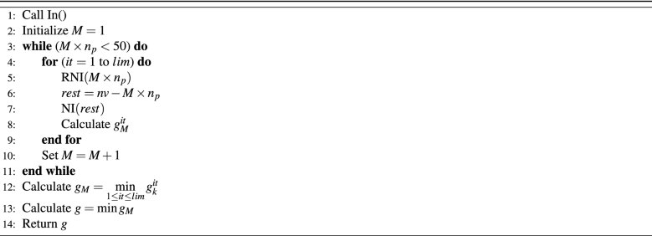

**M-vehicles with randomized-NI and random vehicle algorithm (RR)**

This algorithm works as follows, schedule part of the vehicles using the randomized-NI algorithm as described in the “[M-vehicles with randomized-NI and NI algorithm (RN)](https://www.nature.com/articles/s41598-022-10076-4#Sec18)” section, then schedule the remaining vehicles by applying the random choice of any of the remaining vehicles. The same iteration which is based on the multiplier *M* adopted for NR will be used in this algorithm. This algorithm is denoted by RR.

Part of vehicles with NI and random vehicle algorithm (NRβNRβ)

This algorithm works as follows, schedule part of the vehicles using the NI algorithm, then schedule the remaining vehicles by applying the random choice of any of the remaining vehicles. This algorithm will introduce the percentage that will be used to divide the set of given vehicles. First, define ββ to be the probability that will be used to apply the division. Then, after applying this division, two subsets S1S1 and S2S2, will be generated. The nv×βnv×β first vehicles, will constitute the subset S1S1 and the remaining vehicles will constitute the subset S2S2. The next step is to apply the NI algorithm for S1S1 then apply the random vehicles choice for S2S2. Experimentally, ββ value is in the range of [0.1−0.9][0.1−0.9], with step of 0.1. For all ββ values, iterate the algorithm for *lim* times.

**Iterative randomized-NI algorithm (IR)**

This algorithm works as follows, choose randomly between the two vehicles that has the largest number of people. Indeed, probability σσ will be applied to choose the most loaded vehicle and the probability 1−σ1−σ is applied to choose the second most loaded vehicle. The probability value of is changed several times. In this algorithm, probability values are in the range of {0.1,0.2,0.3,0.4,0.5,0.6,0.7,0.8,0.9}{0.1,0.2,0.3,0.4,0.5,0.6,0.7,0.8,0.9}. The algorithm is repeated for 1000 times, then the best solution is selected.

**Multi-repeating randomized-NI and subset-sum solution algorithm (MR)**

This algorithm works as follows. First, let IR0.4IR0.4 be the algorithm IR with a fixed value of probability of 0.4. Next, the most loaded parking space and the least loaded parking space will be selected. The list that has the vehicles constituted by these latter parking spaces is denoted by Ls. The cardinality of Ls is denoted by nLnL. After that, call the subset-sum procedure to solve the two parking problem, with Ls containing the number of people for each vehicle and nLnL the number of vehicles. A new schedule of two parking will be obtained by the solution of subset-sum. This new schedule will be applied to the two parking spaces, the new *g* value will be calculated and the best solution will be selected. Repeat the IR algorithm call for 40 times and for each call, a subset-sum procedure is applied. The subset-sum procedure applied on list X and number of elements y, is denoted by SS(X,y). After completing all iterations, the best solution is selected. All of these instructions are shown in the algorithm illustrated in Table [6](https://www.nature.com/articles/s41598-022-10076-4#Tab6).

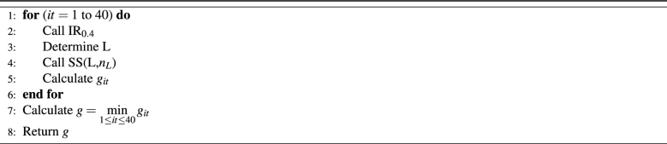

**DATABASE DESCRIPTION**

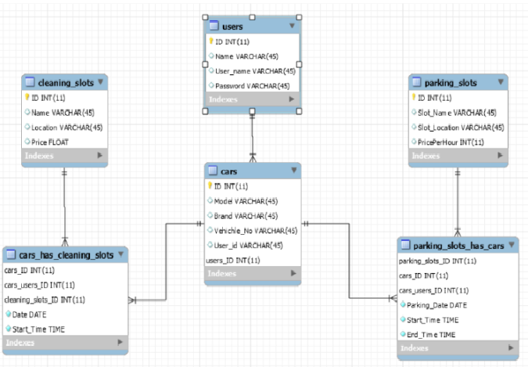

**E-R DIAGRAM**

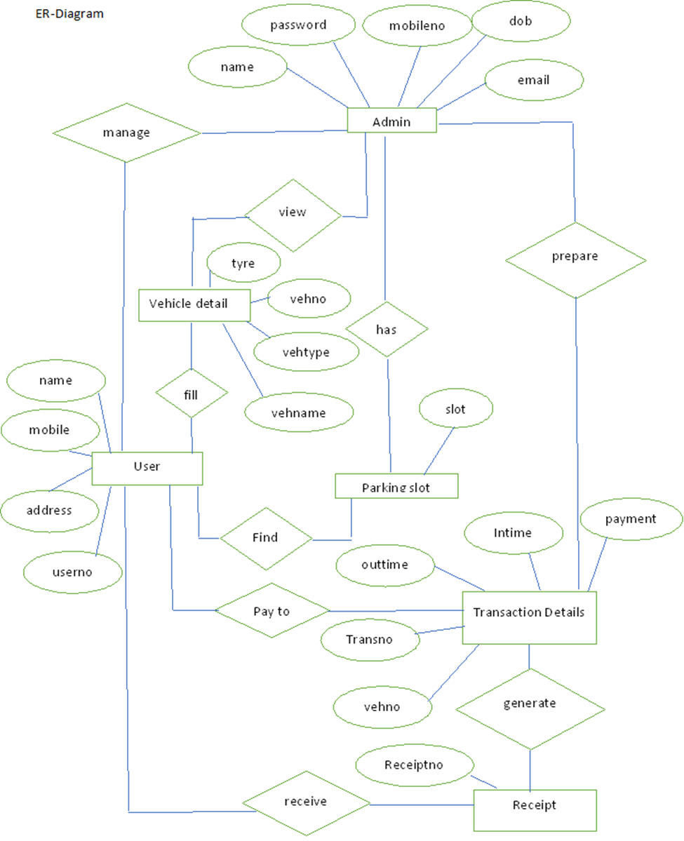

**CLASS DIAGRAM**

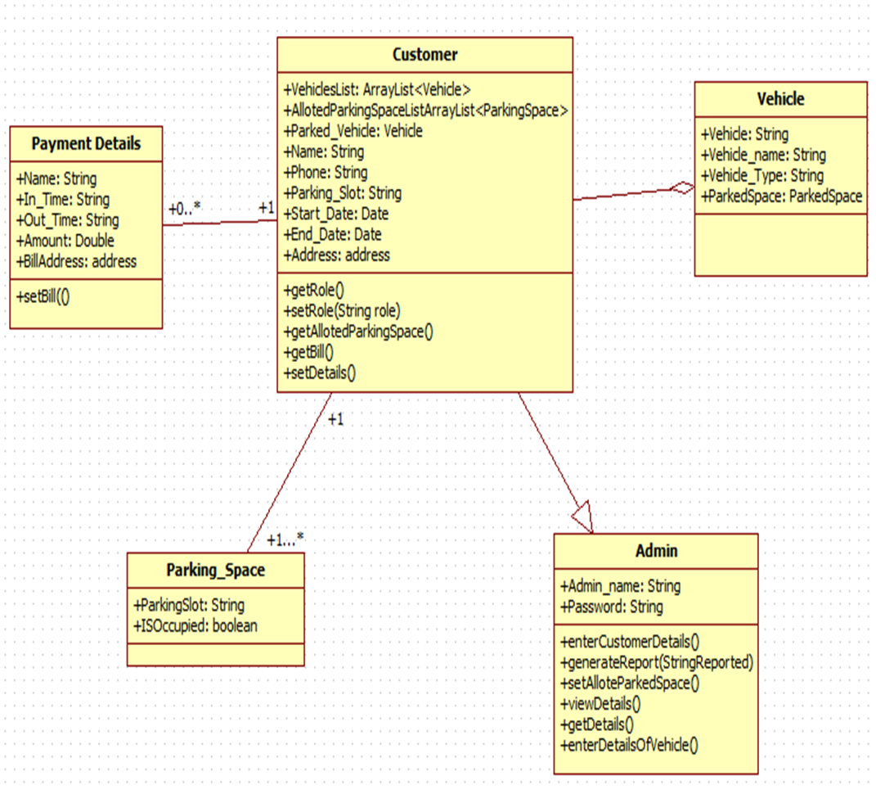

**EXPECTED OUTPUT**

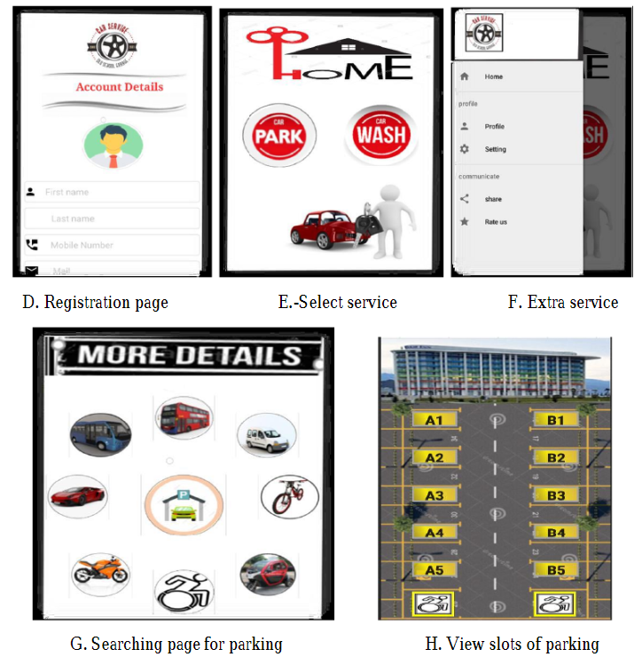

**FUTURE SCOPE**

In the modern age. Many people have vehicles. Vehicle is now a basic need. Every place is under the process of urbanization. There are many corporate offices and shopping centers etc. There are many recreational places where people used to go for refreshment. So, all these places need a parking space where people can park their vehicles safely and easily. Every parking area needs a system that records the detail of vehicles to give the facility. These systems might be computerized or non-computerized. With the help of computerized system we can deliver a good service to customer who wants to park their vehicle into the any organization’s premises.

Vehicle parking management system is an automatic system which delivers data processing in very high speed in systematic manner. Parking is a growing need of the time. Development of this system is very useful in this area of field. We can sell this system to any organization. By using our system they can maintain records very easily. Our system covers the every area of parking management. In coming future there will be excessive need of Vehicle parking management system.

**CONCLUSION**

Smart Parking Management System (SPMS) is used to book parking slots without any great effort by the user using an android device. The user can check the status of parking area and book the parking slot in advance. This will result in overcoming many problems which are being created due to the bad management of the traffic. Mobile computing has proven as the best area of work for researchers in the areas of database and data management so this application is applied in Android Mobile OS. This application is utilized by can be applied nook and corner due to its easy usage and effectiveness.

**REFERENCE**

[1] Faiz Ibrahim Shaikh, Pratik Nirnay Jadhav, Saideep Pradeep Bandarkar, Omkar Pradip Kulkarni, Nikhilkumar B. Shardoor “Smart Parking System Based on Embedded System and Sensor Network”, International Journal of Computer Applications (0975 – 8887) Volume 140 – No.12, April 2016 International Journal of Pure and Applied Mathematics Special Issue 171.

[2] Thanh Nam Pham1, Ming-Fong Tsai1, Duc Binh Nguyen1, Chyi-Ren Dow1, And Der-Jiunn Deng2 “A Cloud-Based Smart-Parking System Based on Internet-of-Things Technologies”,IEEE Access, Received July 24, 2015, accepted August 16, 2015, date of publication September 9, 2015, date of current version September 23, 2015.

3] El Mouatezbillah Karbab, Djamel Djenouri, Sahar Boulkaboul, Antoine Bagula, CERIST Research Center, Algiers, Algeria University of the Western Cape, Cape town, South Africa,”Car Park Management with Networked Wireless Sensors and Active RFID”„,978-1-4799-8802-0/15 ©2015 IEEE.

[4] Mr. Basavaraju S R “Automatic Smart Parking System using Internet of Things (IOT)”, (International Journal of Scientific and Research Publications, Volume 5, Issue 12, December 2015) .

[5] M. M. Rashid, A. Musa, M. Ataur Rahman, and N. Farahana, A. Farhana, “Automatic Parking Management System and Parking Fee Collection Based on Number Plate Recognition.”, International Journal of Machine Learning and Computing, Vol. 2, No. 2, April 2012,Published 2014.

[6] Hilal Al-Kharusi, Ibrahim Al-Bahadly, “Intelligent Parking Management System Based on Image Processing”, World Journal of Engineering and Technology, 2014, 2, 55-67.

[7] X. Zhao, K. Zhao, and F. Hai, ``An algorithm of parking planning for smart parking system,'' in Proc. 11th World Congr. Intell. Control Autom. (WCICA), 2014, pp. 4965_4969.

[8] L. Mainetti, L. Palano, L. Patrono, M. L. Stefanizzi, and R. Vergallo,``Integration of RFID and WSN technologies in a smart parking system,''in Proc. 22nd Int. Conf. Softw., Telecommun. Comput. Netw. (SoftCOM), 2014, pp. 104_110.

[9] Harmeet Singh, Chetan Anand, Vinay Kumar, Ankit Sharma, “Automated Parking System With Bluetooth Access”, International Journal Of Engineering And Computer Science ISSN:2319-7242,Volume 3 Issue 5, May 2014, Page No. 5773-5775